Classification of Organic Materials with, Quantitative Determination by, and Comparison of Different Solvents in Fourier Transform-Infrared Spectroscopy

Max Shi

*Department of Chemistry, Stevens Institute of Technology, Castle Point on Hudson, Hoboken, NJ 07030.*

*Performed October 19, 2020; submitted October 27, 2020.*

**Abstract:** In this experiment, FT-IR Spectroscopy was used for many different purposes. In the first part of the experiment, the spectra of many different organic plastics were measured, as well as three unknown organic plastics. Using the peaks on the spectra, and comparing the peaks of the unknown spectra to the known spectra, it was identified that the first unknown was PETE, the second unknown was also PETE, and the third unknown was closest to PS.

The second experiment involved the identification of an unknown compound dissolved in solution. In this portion, three known compounds, cyclohexane, ethyl acetate, and methyl ethyl ketone were dissolved, and their spectra were measured. Then, an unknown spectrum was measured. By comparing the peaks in the absorption spectrum, the unknown was identified to be cyclohexane.

The third experiment was using FT-IR spectroscopy to determine the unknown concentration of a solution of methyl ethyl ketone. After being given calibration solutions of 0.4%, 0.8%, 1.2%, and 1.6% MEK v/v solutions, their spectra were taken and the wavelength of 1725.61 cm-1 was selected as the wavelength where the peak intensity varied by concentration. Thus, by taking the spectrum of the unknown and recording the absorption at that wavelength, ordinary linear calibration could be used to determine the concentration of the unknown solution, which was 1.26%.

The fourth experiment was the comparison of two different solvents for measuring solid compounds with FT-IR spectroscopy. The first solvent was a KBr pellet, while the second solvent was Nujol. While their spectra were very similar, it seems that the percent transmission in the KBr pellet is much higher than in the Nujol method, which resulted in much more drastic peaks to be read on the spectrum.

**Introduction**

Fourier Transform-Infrared Spectroscopy is a method used to determine the identity of solids, liquid, gases, and compounds in solution, and can also be used to determine the concentration of compounds in solution, however, this use is less common. FT-IR spectroscopy takes advantage of the movement of bonds when an infrared beam is passed through the compound. When infrared passes through organic compounds, depending on the bond connectivity in the compound, which can include factors like atomic weight of the atoms, polarity, and bond strength, different bonds vibrate and move differently, and therefore, absorb different wavelengths of infrared light. Therefore, infrared light shining through the sample will be absorbed at different intensities at different wavelengths, and the final transmittance can be measured with an IR detector. This setup is illustrated in Figure 1. By looking at the intensity, shape, and location of curves on the resulting absorption spectrum, different types of bonds can be pinpointed in the compound, and the determination of a compound’s identity can be made. Furthermore, because an increased concentration of a compound will increase the absorption at a certain wavelength, Beer’s Law still applies, so techniques like standard ordinary linear calibration can still apply to this technique to recover unknown concentrations of a compound.

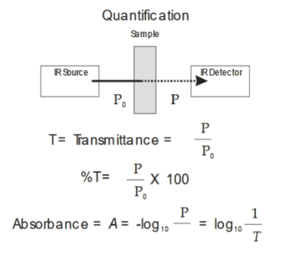

Figure : Diagram of FT-IR Spectroscopy Setup

Setup for this technique varies based on the state of matter of the sample. Liquids and solutions are prepared with a demountable NaCl cell, where the path length is set and the solution is piped into the cell. This cell is put directly into the machine. For solid substances, different techniques can be used, such as Horizontal Attenuated Total Reflectance, which directly uses the material as a thin film to measure, or the Pellet method, which is the creation of a compressed pellet with a mixture of the ground up solid sample and KBr powder, or Nujol, which mixes a ground up solid sample with Nujol mineral oil between two NaCl plates. Each of these samples can be placed into the machine with their respective holding plates and setups, and their FT-IR spectra will have the same shape and relative intensity.

**Results and Discussion**

In the first part of this experiment, solid plastic samples were analyzed with the Horizontal Attenuated Total Reflectance method. Small films of the plastic were loaded into the machine, a Perkin Elmer Spectrum Two, and each sample’s spectrum was taken. Figures 1-5 depict the spectra and annotated peaks of the known samples, which were high-density polyethylene (HDPE), low-density polyethylene (LDPE), polyethylene terephthalate (PETE), polypropylene (PP), and polystyrene (PS).

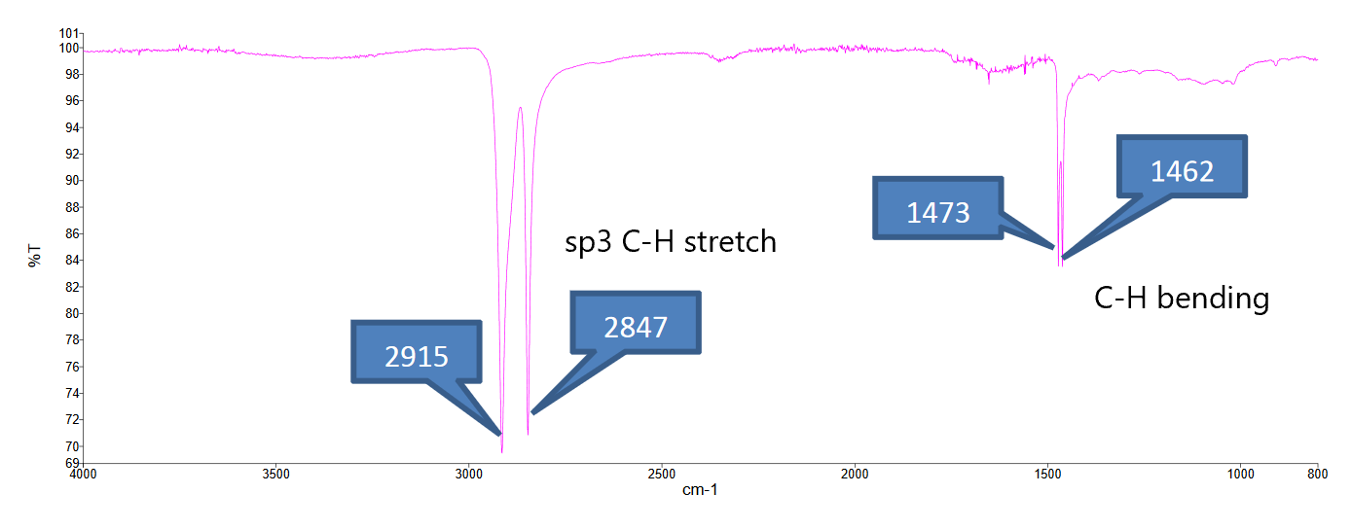

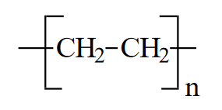

Figure : IR Absorption Spectra of HDPE

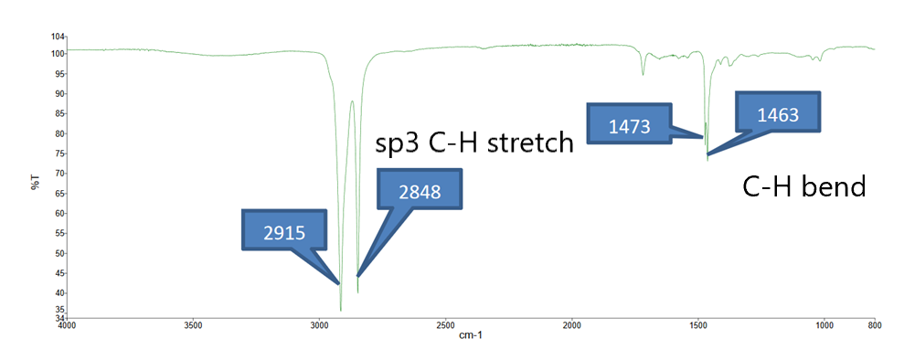



Figure : IR Absorption Spectra of LDPE

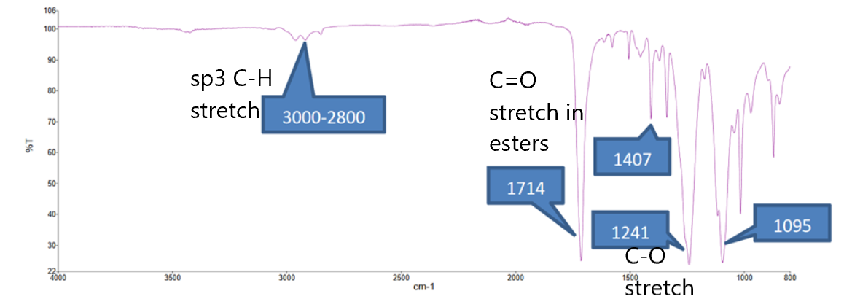

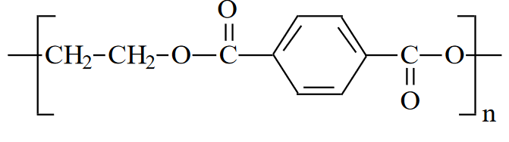

Figure : IR Absorption Spectra and Structure of PETE

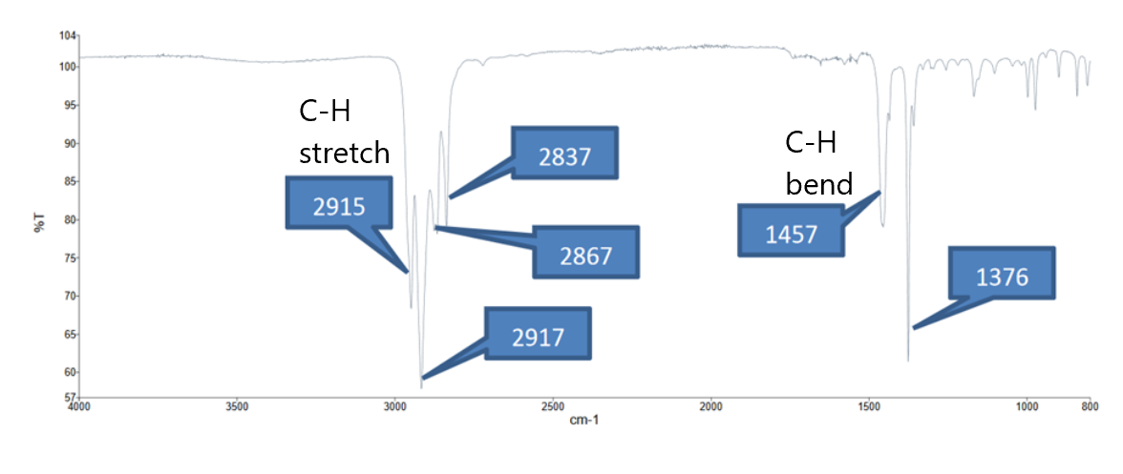

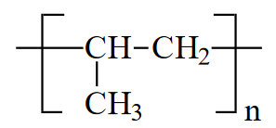

Figure : IR Absorption Spectra of PP

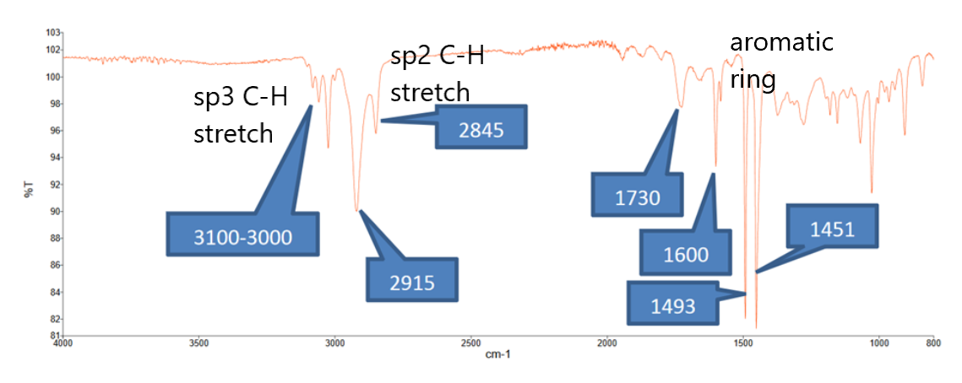

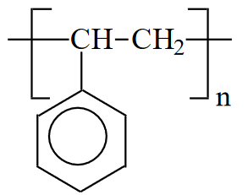

Figure : IR Absorption Spectra of PS

Using the spectra of the first unknown, depicted in Figure 7, from a plastic soda bottle, characteristic peaks are seen at 1713 cm-1, 1240 cm-1, and 1095 cm-1, along with a small peak at 1408 cm-1. A very telling characteristic of this spectra is also the lack of a peak at 3000-2800 cm-1, where C-H bonds tend to show on the spectrum. This spectra is almost identical to the spectra of PETE, and therefore, the material in the plastic soda bottle was characterized to be PETE.

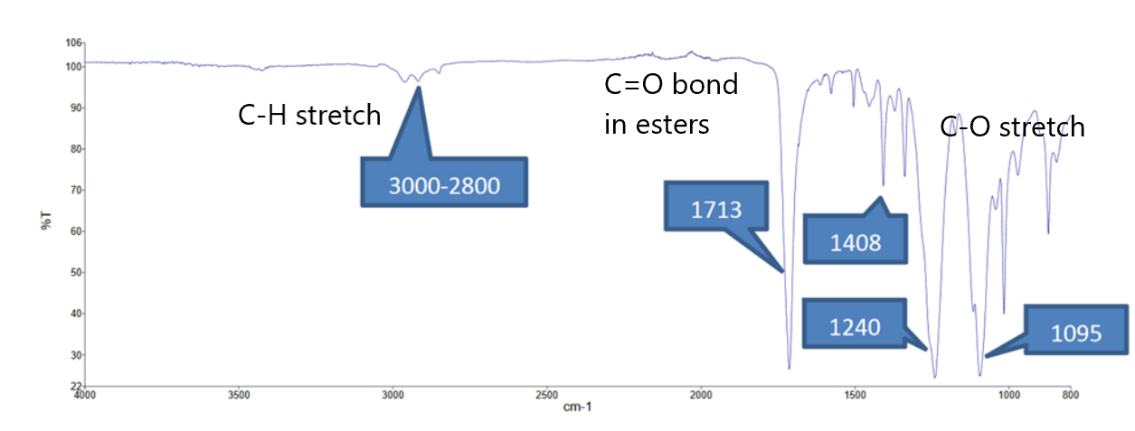

Figure : IR Absorption Spectra of Unknown 1 (Plastic Soda Bottle)

The spectra of the second unknown, taken from the plastic liner of an aluminum soda can, is a little less clear than the first one. The region between 3000-2800 cm-1 is not as strong as plastics like LDPE or HDPE, however, not as weak as it was with PETE. Peaks are characteristic of both PETE and PS, as the medium sized peak at 1730 cm-1 of PS is present, however, a peak down the spectrum at 1036 cm-1 is also present, which is nonexistent in pure PS, but lower wavelength peaks exist in PETE. Two peaks in at 1234 and 1241 cm-1 further complicate the situation, as this is not present in any of the known compounds. The closest is the single 1240 cm-1 peak in PETE. Furthermore, the unknown spectrum contains a small dip around the 3400 cm-1 point, which signifies a O-H bond. Therefore, unknown 2 could not be definitively identified, but it can be hypothesized that the bond connectivity of unknown 2 is similar to that of PETE, as it shows the most characteristics of this compound.

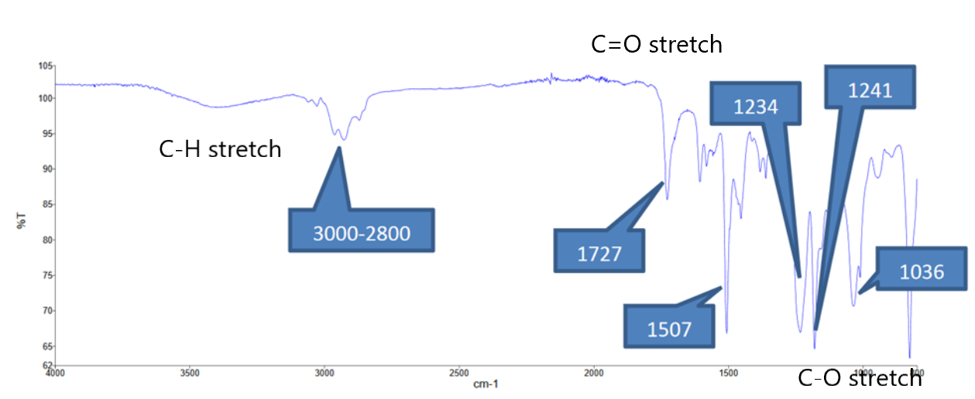

Figure : IR Absorption Spectrum of Unknown 2 (Liner of Aluminum Soda Can)

The final unknown sample in this portion of the experiment was given by the TAs of the course. The spectrum has much less intense peaks than the other samples, but there are still characteristic peaks at 2915, 1730, 1495, and 1451 cm-1. This is in line with the spectrum of PS, so the identity of unknown 3 was concluded to be polystyrene.

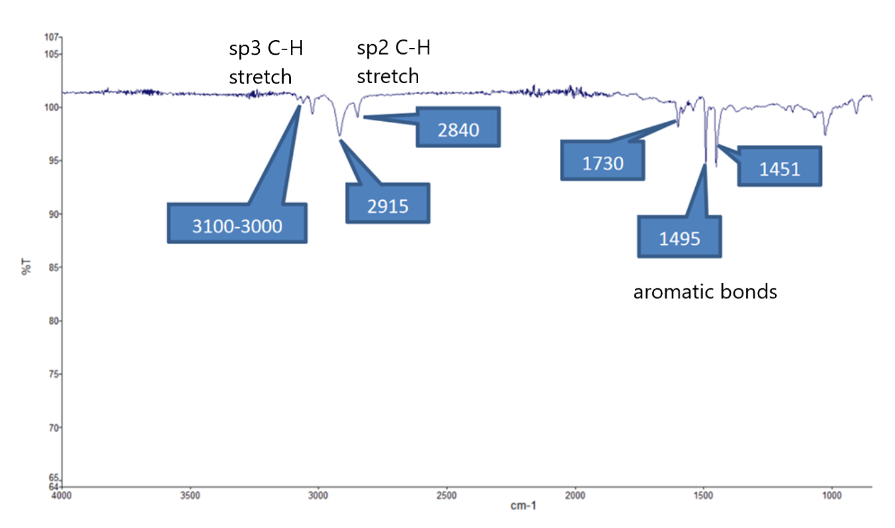

Figure : Absorption Spectrum of Unknown 3

In conclusion regarding the first part of this experiment, FT-IR spectroscopy for determination of unknown compounds is very important in forensics. With forensics, applying science to solving crimes, often, evidence left behind has some sort of organic material on it, whether it be plastic bottles, clothing, or even trace elements of drugs and other similar substances. A paper on uses of FT-IR spectroscopy and related techniques by the FCC details specific examples of its usefulness.

IR spectroscopy was used in the investigation of pet food laced with toxic melamine and other nitrogen-rich chemicals to pass total measured nitrogen tests. Melamine, which reacts with naturally occurring cyanuric acid, forms melamine cyanurate, which causes renal failure in pets which consumed the food. Thus, autopsies were conducted with a deceased cat’s tissue, where the cause of death was suspected to be from consuming tainted pet food. IR spectrometry was used on kidney tissue to look for the presence of melamine cyanurate.

In other applications, suspected counterfeit combination drugs were investigated with FT-IR to determine the presence of the advertised active ingredient. FT-IR spectroscopy combined with imaging allows for the determination of the presence of each individual compound in the drug, as the active ingredients had to be spatially separated from each other. While this process was not covered in this lab itself, FT-IR imaging and spectroscopy in combination is useful to determine specific compounds in mixtures as well.

Finally, another application of FT-IR spectrometry is the determination of the identity of trace compounds attached to evidence. When examining a trace white powder on two different bottles, FCC officials used FT-IR spectroscopy and imaging to determine one of the substances as a derivative of cocaine, and the other substance as methandrostenolone, both controlled substances in the US.

The second part of the experiment involved carrying out the same identification process as the first portion, but with solutions instead of solid films. Three solutions of 3% v/v cyclohexane, ethyl acetate, and methyl ethyl ketone were given by the TAs, as well a solution of unknown identity. Each sample was loaded into the demountable NaCl cell and an absorption spectrum was measured. Each spectrum, as well as the associated compound, is depicted in Figures 10-13.

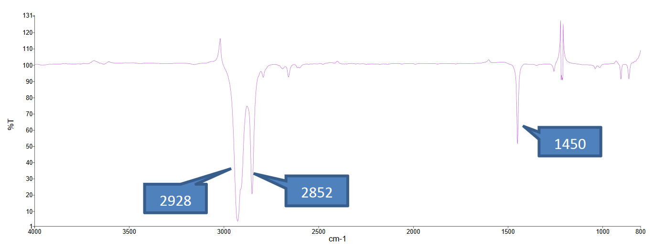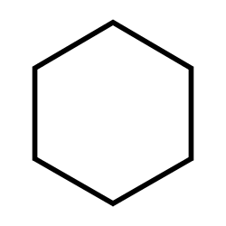

Figure 10: IR Absorption Spectrum and Structure of Cyclohexane

The peaks at 2928 and 2852 cm-1 are representative of the C-H stretch for sp3 carbons, and the peak at 1450 cm-1 is representative of the C-H bending.

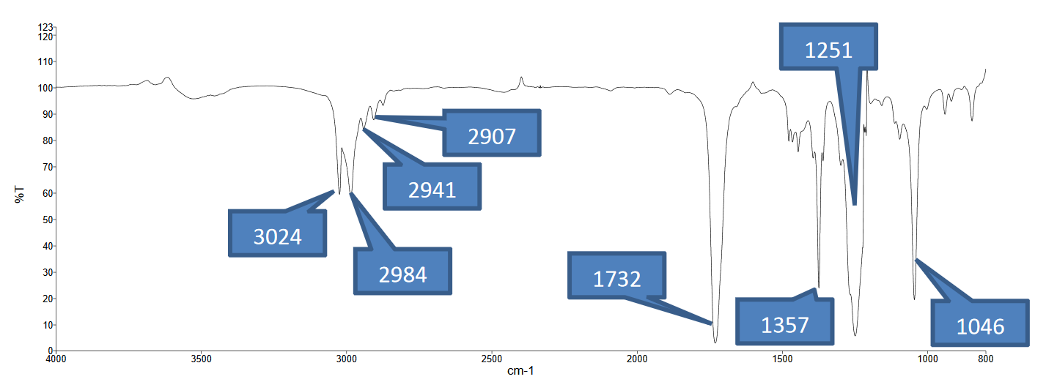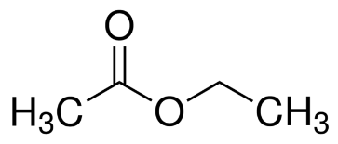

Figure 11: IR Absorption Spectrum and Structure of Ethyl Acetate

In the spectrum of ethyl acetate, the peaks between 3024-2907 cm-1 are associated with C-H stretching for sp3 carbons, the peak at 1732 cm-1 is associated with C=O stretching, the peak at 1357 cm-1 is associated with C-H bending, the peak at 1251 cm-1 is associated with C-O stretching with the ester, and 1046 cm-1 is associated with C-O stretching with between the sp3 carbon.

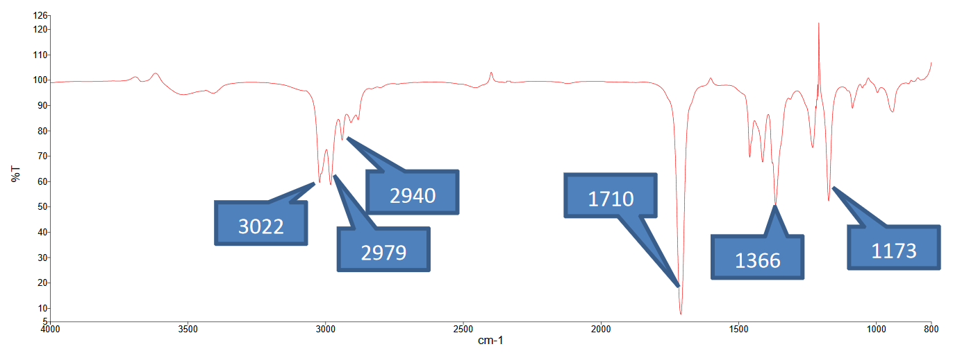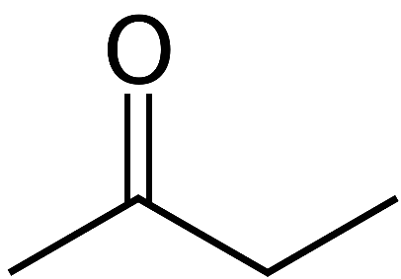

Figure 12: IR Absorption Spectrum and Structure of Methyl Ethyl Ketone

In the spectrum of methyl ethyl ketone, the peaks between 3022-2940 cm-1 are associated with C-H stretching for sp3 carbons, the peak at 1710 cm-1is associated with C=O stretching, the peak at 1366 cm-1 is associated with C-H bending, and the peak at 1173 cm-1 is associated with C-O stretching.

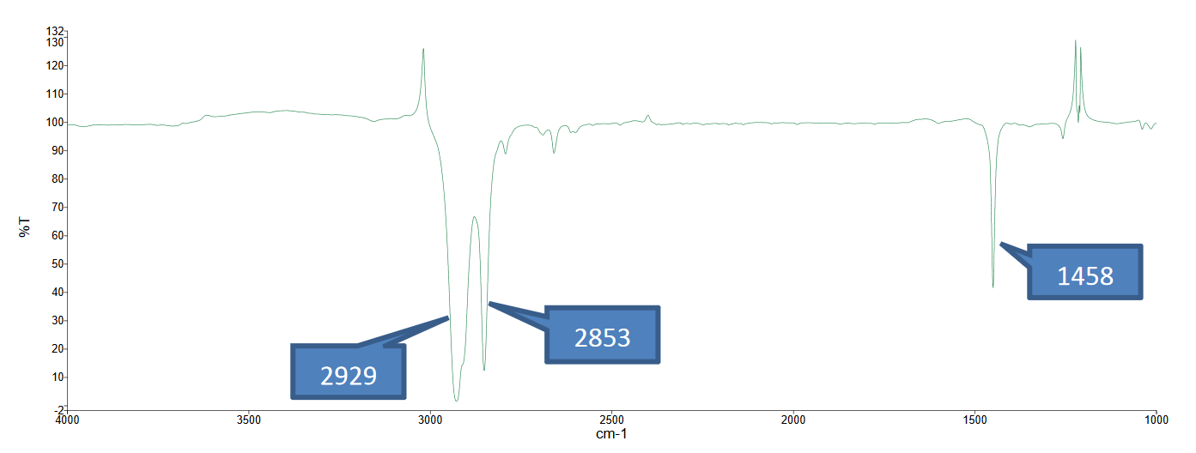

Figure 13: IR Absorption Spectrum of Unknown

The absorption spectrum of the unknown compound is almost identical to the absorption spectrum of cyclohexane, where the peaks are in the same location (+/- 10 cm-1) and the relative intensities are very similar. Thus, the identity of the unknown is concluded to be cyclohexane.

The third part of the experiment involved using FT-IR spectroscopy to determine the unknown concentration of a solution of methyl ethyl ketone. To accomplish this, the spectra of four calibration solutions of MEK were taken, at 0.4%, 0.8%, 1.2%, and 1.6% v/v, in the same method as the second part of this experiment by loading the samples into the demountable NaCl cell. Then, the unknown spectrum was also taken with the FT-IR machine. The overall overlaid spectrum is depicted in Figure 14.

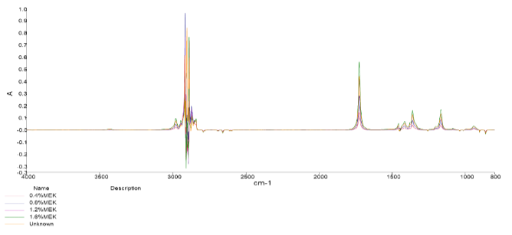

Figure : Overlaid IR Spectrum of MEK Solutions

From this overlaid spectrum, the wavelength of 1725.61 cm-1 was determined to be the peak which varied by concentration the most. Thus, this wavelength was chosed as the wavelength to take absorption measurements for ordinary linear calibration. The magnified plot is depicted in Figure 15, and the linear calibration plot generated from the measured absorption vaules is depicted in Figure 16.

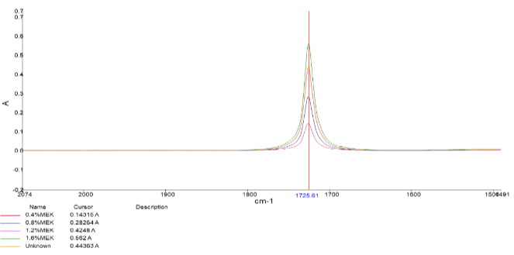

Figure : Magnified Plot of Overlaid IR Spectrum at 1725.61 cm-1

Figure : Linear Calibration Plot for MEK

The absorbance value of the unknown was 0.444 A, which, when plugged into the linear regression equation, yielded a concentration of 1.26% v/v MEK.

The fourth part of this experiment was comparing the use of two different solvents for FT-IR when analyzing solid samples, in this case, benzoic acid. The first method was with the Pellet method, where a few milligrams of crushed sample of benzoic acid was mixed with 0.5 to 1g of powdered KBr and compressed into a pellet. This pellet was loaded into a cell, and an FT-IR spectrum was taken. The second method was the Nujol mull method, where about 0.1g benzoic acid was mixed a drop of Nujol, a type of mineral oil, ground into a mixture, and pressed between two NaCl salt places. Then, the plates were loaded into the machine and an IR spectrum was taken. The two resulting spectra are depicted in Figure 17 and 18.

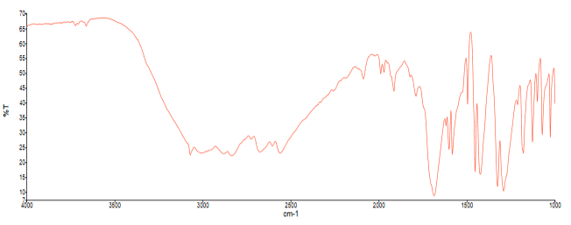

Figure : IR Spectrum of Benzoic Acid with Pellet Method

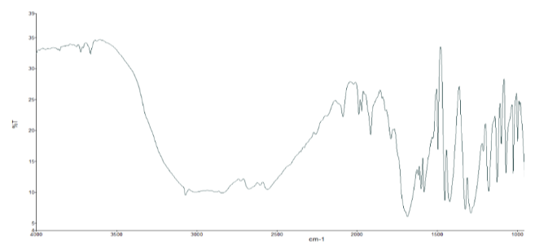

Figure : IR Spectrum of Benzoic Acid with Nujol Mull Method

While the shape of the peaks are very similar, there are subtle differences between the spectrums. The IR spectrum of the Pellet method starts at around 66% T, while the Nujol mull method starts at about 33% T. This extends the y axis and sharpens some of the curves where the absorption is very high, such as the peak around 1700 cm-1. At this peak, while the raw absorption values might be the same, the greater scale on the Pellet method gives a greater indicator as to how truly sharp the absorption is at that point. Another difference is the smoothness of the peak between 3200-2500 cm-1, where the Pellet method introduces jagged peaks and the Nujol mull shows a smoother peak over the region. Another slight difference is the intensity of the peaks between 2200-1900 cm-1, where the Pellet method seems to be less intense than the Mujol null in this case. However, besides some slight differences in the intensity of the peaks, each of the peaks are in the same location, and the same information could be deduced from the spectra regarding the identity of the benzoic acid.

**References**

1. Attygalle, A. Instrumental Analysis I Lecture and Laboratory Manual <https://sit.instructure.com/courses/38802/files/6982711?module_item_id=1042514> (accessed Oct 11, 2020).
2. Harris, D. C. *Quantitative Chemical Analysis*, 8th ed.; W.H. Freeman and Co: New York, 2010. Chapter 19.
3. Lanzarotta, A. Analysis of Forensic Casework Utilizing Infrared Spectroscopic Imaging. *Sensors (Basel)* **2016**, *16* (3). <https://doi.org/10.3390/s16030278>.